* Copyright for test papers and marking guides remains with *West Australian Test Papers*.
* The papers may only be reproduced within the purchasing school according to the advertised conditions of sale.
* Test papers must be withdrawn after use and stored securely in the school until Friday June 14

**HUMAN BIOLOGY**

**Unit 3**

**2019**



Name: _______________________________________________________

Teacher: ___________________________________________________

***TIME ALLOWED FOR THIS PAPER***

Reading time before commencing work: Ten minutes

Working time for the paper: Three Hours

***MATERIALS REQUIRED/RECOMMENDED FOR THIS PAPER***

**To be provided by the supervisor:**

* This Question/Answer Booklet
* Multiple Choice Answer Sheet

**To be provided by the candidate:**

* Standard items: Pens, pencils, eraser or correction fluid, ruler, highlighter.
* Special items: Calculators satisfying the conditions set by the Schools

Curriculum and Standards Authority for this subject.

***IMPORTANT NOTE TO CANDIDATES***

* No other items may be taken into the examination room. It is **your** responsibility to ensure that you do not have any unauthorised notes or other items of a non-personal nature in the examination room. If you have any unauthorised material with you, hand it to the supervisor **before** reading any further.

***Structure of this paper***

|  |  |  |  |  |  |
| --- | --- | --- | --- | --- | --- |
| Section | Suggested working time | Number of questions available | Number of questions to be attempted | Marks | Percentage |
| SECTION ONE:  Multiple-choice | 50 minutes | 30 | All | 30 | 30 |
| SECTION TWO:  Short answers | 90 minutes | 6 | All | 100 | 50 |
| SECTION THREE:  Extended answers | 40 minutes | 3 | 2 | 40 | 20 |
|  |  |  | Total marks | 170 | 100 |

**Instructions to candidates**

1. The rules for the conduct of Western Australian external examinations are detailed in the *Year 12 Information Handbook 2019.* Sitting this examination implies that you agree to abide by these rules.

2. Answer the questions according to the following instructions.

Section One: Answer all questions on the separate Multiple-choice Answer Sheet provided. For each question shade the box to indicate your answer. Use only a blue or black pen to shade the boxes. If you make a mistake, place a cross through that square, do not erase or use correction fluid, and shade your new answer. Marks will not be deducted for incorrect answers. No marks will be given if more than one answer is completed for any question.

Sections Two and Three: Write your answers in this Question/Answer Booklet.

3. You must be careful to confine your responses to the specific questions asked and to follow any instructions that are specific to a particular question.

4. Spare pages are included at the end of this booklet. They can be used for planning your responses and/or as additional space if required to continue an answer.

* Planning: If you use the spare pages for planning, indicate this clearly at the top of the page.
* Continuing an answer: If you need to use the space to continue an answer, indicate in the original answer space where the answer is continued, i.e. give the page number. Fill in the number of the question(s) that you are continuing to answer at the top of the page.

**Section One: Multiple-choice 30% (30 Marks)**

This section has **30** questions. Answer **all** questions on the separate Multiple-choice Answer Sheet provided. For each question shade the box to indicate your answer. Use only a **blue or black pen** to shade the boxes. If you make a mistake, place a cross through that square, do not erase or use correction fluid, and shade your new answer. Marks will not be deducted for incorrect answers. No marks will be given if more than one answer is completed for any question.

Suggested working time: 50 minutes.

1. The organ(s) responsible for the control of sleep patterns and waking is thought to be the
2. hypothalamus and medulla oblongata.
3. medulla oblongata.
4. pineal gland and hypothalamus.
5. parathyroid gland.
6. The thymus gland is thought to be responsible for
7. influencing the maturation of T cells.
8. stimulating the growth of ovarian follicles.
9. promoting milk production.
10. the contraction of smooth muscle in the uterus and mammary glands.
11. A scientific experiment must have a control. The control is needed to
12. ensure only one variable is tested at a time.
13. indicate what effect the independent variable has had on the results.
14. decrease the number of outliers in the results.
15. indicate if any similarities are due to the controlled variables.

**Use the diagram below to answer Question 4.**

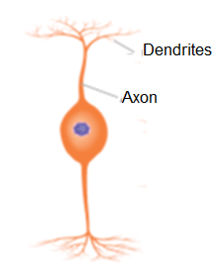

1. Which of the following correctly labels the structural type, impulse direction and location of the neuron shown above.

|  |  |  |  |
| --- | --- | --- | --- |
|  | Structural Type | Impulse direction | Location |
| (a) | Bipolar | From receptor cells to other neurons | Eye and ear |
| (b) | Unipolar | From spinal cord to motor neurons | Spinal cord |
| (c) | Motor | Receives impulses from spinal cord | Skeletal muscles |
| (d) | Multipolar | Receive from interneurons | Organs |

1. The difference between white and grey matter within the brain is that:
2. the white matter is found on the outside of the brain whilst the grey matter is inside.
3. the grey matter contains the unmyelinated nerve fibres and the white matter contains the cell bodies.
4. the white matter contains the dendrites of neurons, the grey matter contains the nerve fibres.
5. the grey matter contains the cell bodies of neurons, the white matter contains the myelinated nerve fibres.
6. Many nerve fibres consist of an axon covered with a myelin sheath and a neurilemma. The neurilemma is
7. responsible for the repair of injured fibres.
8. produced by Schwann cells located along the dendrite.
9. continuous all the way along the cell body.
10. responsible for the colour of the grey matter in the central nervous system.
11. The process that involves the decomposition of hormones is called
12. negative feedback.
13. enzyme amplification.
14. hormone clearance.
15. hormone amplification.

**Refer to the following diagram, showing the processes involved in breast feeding, to answer the next THREE questions.**

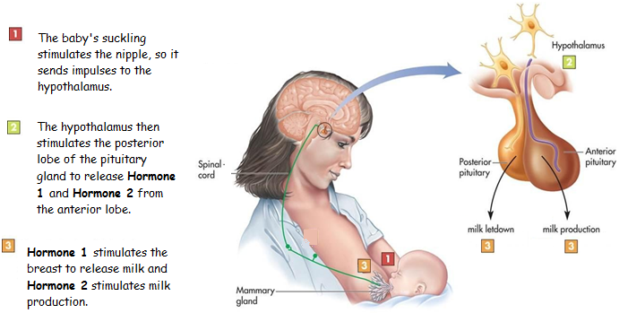

1. In this stimulus-response and feedback process, the modulator would be the
2. nipple and areola.
3. hypothalamus
4. pituitary gland
5. oxytocin.
6. The type of feedback involved in this process would be
7. negative feedback, as the response negates the stimulus.
8. positive feedback, as the response negates the stimulus.
9. negative feedback, as the response intensifies the stimulus.
10. positive feedback, as the response intensifies the stimulus.
11. Hormone 2 differs to Hormone 1 because Hormone 2 is
12. produced in and released from the anterior lobe of the pituitary.
13. produced in the hypothalamus and sent to the anterior lobe of the pituitary via nerve fibres.
14. produced in the hypothalamus and sent to the anterior lobe of the pituitary via blood vessels.
15. secreted from the hypothalamus and sent to the anterior lobe of the pituitary via blood vessels in the infundibulum.
16. Which of the following statements about the visceral sensory neurons are correct?
17. They relay impulses from the central nervous system to the skin and muscles.
18. They transmit impulses from the internal organs to the central nervous system.
19. They relay impulses from the skin and muscle to the central nervous system.
20. They transmit impulses from the central nervous system to involuntary muscles.
21. The autonomic nervous system is regulated by a group of nerve cells in the
22. medulla oblongata and cerebral cortex.
23. hypothalamus and cerebral cortex.
24. hypothalamus and thalamus.
25. medulla oblongata, hypothalamus and cerebral cortex.
26. Which of the following cell organelles are stimulated to release a neurotransmitter from an axon terminal?
27. Vesicles.
28. Lysosomes.
29. Centrioles.
30. Receptor protein.
31. Which of the following statements about the autonomic division of the peripheral nervous system is correct?
32. This system is under voluntary control and can inhibit or excite the effector.
33. It is made up of two nerve fibres that may excite or inhibit the effector.
34. It contains sensory neurons that respond to external environmental changes.
35. The autonomic division releases acetylcholine and is responsible for maintaining homeostasis.
36. The nervous and endocrine systems differ in how they control body functions. The nervous system differs from the endocrine system as the nervous system
37. transfers neurotransmitters through the bloodstream.
38. provides positive feedback to stimuli.
39. provides impulses that travel to specific parts of the body and stimulate one effector.
40. provides impulses that travel to all parts of the body and stimulate one effector.
41. The function of the ________ is to enable the two sides of the cerebrum to communicate with each other.
42. Corpus callosum
43. Medulla oblongata
44. Basal ganglia
45. Cerebellum
46. Bacteria
47. contain DNA or RNA, but not both.
48. contain organelles surrounded by a protein coat.
49. are considered to be non-living organisms.
50. possess a cell membrane surrounded by a cell wall.
51. Bacteriostatic antibiotics are effective at killing bacterial infections because they
52. stop bacteria from reproducing.
53. prevent the bacteria from growing.
54. disrupt cellular respiration.
55. disrupt the action of essential enzymes.
56. Which of the following types of immunity is responsible for vaccinating a large proportion of the population, making it difficult for an infectious disease to spread?

1. Passive immunity
2. Herd immunity
3. Active immunity
4. Living attenuated
5. Which of the following best describes a non-specific external defence that stops pathogens from entering the body.

|  |  |  |
| --- | --- | --- |
|  | Type of defence | Strategy applied |
| (a) | Stomach acid | Increases the pH of the environment killing any pathogens. |
| (b) | Cilia | Tiny hair-like projections covered in mucus that capture pathogens in the respiratory system. |
| (c) | Cerumen | An oily substance released onto the skin to trap pathogens. |
| (d) | Lysozyme | An alkaline substance that kills bacteria, found in tears and sweat. |

1. When the hormone glucagon reaches a target cell, it attaches to a receptor protein. This causes a secondary messenger to be released which activates a specific enzyme in the cell.

Glucagon is a

1. water soluble steroid hormone.
2. lipid soluble steroid hormone.
3. water soluble protein hormone.
4. lipid soluble protein hormone.
5. As a result of a brain injury, an individual now has difficulty breathing and needs to take conscious control periodically to maintain their oxygen levels. The part of their brain most likely damaged would be their
6. hypothalamus.
7. cerebral cortex.
8. cerebellum.
9. medulla oblongata.

**Refer to the picture below to answer the next question.**

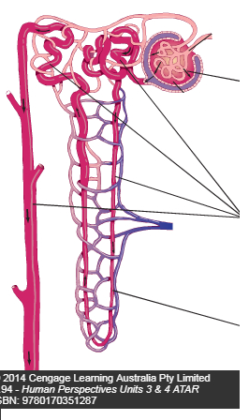

3

2

1

1. Which of the following correctly identifies the processes occurring to produce urine?

|  |  |  |  |
| --- | --- | --- | --- |
|  | 1 | 2 | 3 |
| (a) | Secretion | Filtration | Reabsorption |
| (b) | Reabsorption | Secretion | Filtration |
| (c) | Filtration | Reabsorption | Secretion |
| (d) | Filtration | Reabsorption | Urination |

1. Natural active immunity can be obtained by
2. antibodies entering the blood stream across the placenta.
3. antigens entering the blood stream via air droplets.
4. providing antibodies through an injection.
5. antigens entering the bloodstream via a vaccine.
6. Which of the following statements **correctly** presents a difference between antibiotics and vaccines?
7. Antibiotics do not provide immunity, while vaccines can provide active artificial immunity.
8. Antibiotics provide long term immunity through memory cells, while vaccines provide short term immunity.
9. Antibiotics are a type of active artificial immunity, while vaccines are passive artificial immunity.
10. Antibiotics are often injected into the bloodstream and vaccines are ingested as a pill.
11. Which of the following symptoms would a person suffering from hyperthyroidism be likely to show?
12. weight loss
13. increased body surface temperature
14. intolerance to cold
15. weight gain

**The following information is needed to answer the next FOUR questions.**

In 2002, Dr Karl Kruszelnicki conducted a survey through the internet to find out what type of personal traits resulted in the greatest amount of belly button lint. The age groups that provided the most meaningful statistics can be seen below.

|  |  |  |  |  |  |  |  |  |
| --- | --- | --- | --- | --- | --- | --- | --- | --- |
| Age range | 16 – 20 | 21 – 25 | 26 - 30 | 31 – 35 | 36 - 40 | 41 - 45 | 46 – 50 | 51 - 55 |
| Number of people with belly button lint. | 768 | 732 | 700 | 692 | 486 | 440 | 145 | 62 |

1. The percentage of 26 – 30 year olds that represented the total sample frame was
2. 33.2%.
3. 5.75%.
4. 20%.
5. 17.4%.
6. The median number of people who responded to the survey who get belly button lint is
7. 503
8. 692
9. 589
10. 486
11. The percentage change in the presence of belly button lint from the 16 – 20 to 51 – 55 age group is a
12. 10.1% increase.
13. 91.9% decrease.
14. 10.1% increase.
15. 91.9% increase.
16. The most correct term used to describe the data obtained from this survey is
17. quantitative data.
18. reliable data.
19. qualitative data.
20. valid data.

**Section Two: Short answer 50% (100 Marks)**

This section has **six (6)** questions. Answer **all** questions. Write your answers in the spaces provided.

Spare pages are included at the end of this booklet. They can be used for planning your responses and/or as additional space if required to continue an answer.

* + Planning: If you use the spare pages for planning, indicate this clearly at the top of the page.
  + Continuing an answer: If you need to use the space to continue an answer, indicate in the original answer space where the answer is continued, i.e. give the page number. Fill in the number of the question(s) that you are continuing to answer at the top of the page.

Suggested working time: 90 minutes.

**Question 31 (19 marks)**

Pepper spray is a chemical substance dispersed from an aerosol can to cause temporary blindness and physical discomfort in people or animals. It is used by police, so they can easily detain aggressive suspects. Capsaicin is the chemical responsible for causing the irritations the victim experiences and the two homeostatic mechanisms described below.

Capsaicin is capable of binding to the active site of capsaicin (TRPV1) receptor proteins located within the cell membrane of C nerve fibres, which are located within the skin and muscles. These receptors are normally stimulated by surface temperatures greater than 43°C. When these protein channels are opened, a gradual and slow burning sensation can be felt by the subject, causing them to break out into a heavy sweat. Furthermore, when stimulated by capsaicin, the C nerve fibres release a variety of paracrines called neuropeptides. These chemicals bind to and stimulate mast cells, in response to the capsaicin.

1. State which division of the nervous system the C nerve fibres are placed in and explain why. (3 marks)

________________________________________________________________________________________________________________________________________________________________________________________________________________________________________________________________________________________________

1. Using the space provided below, draw and label a diagram of a unipolar C neuron.

(2 marks)

1. Using the diagram drawn for Question 31 (b), draw and label an arrow in the box that shows the direction the impulse would travel through the C neuron. (1 mark)
2. A specific structural feature of the C neuron axon is absent and gives rise to its ability to provide a slow burning sensation. State what this missing feature is and describe why it provides a slow burning sensation, in contrast to a neuron that provides a rapid pain message. (4 marks)

________________________________________________________________________________________________________________________________________________________________________________________________________________________________________________________________________________________________

1. When someone is subjected to pepper spray, they usually react by producing excessive tears and mucus, become red and hot in the face and have swelling around the eyes. They also experience a slow burning sensation, which results in heavy sweating.
   1. Name and describe the process that would lead to the subject producing excessive mucus, becoming red and hot in the face and have swelling around the eyes. (5 marks)

________________________________________________________________________________________________________________________________________________________________________________________________________________________________________________________________________________________________

________________________________________________________________________________________________________________________________________________

* 1. Describe two (2) responses that would occur to cause the subject to sweat heavily and become red in the face and explain how these responses would lower their body temperature. (4 marks)

________________________________________________________________________________________________________________________________________________________________________________________________________________________________________________________________________________________________

________________________________________________________________________

**Question 32 (21 marks)**

**Food allergy occurs in around 5-10% of children in Australia. Some food allergies can be severe, resulting in potentially life-threatening allergic reactions. Oral immunotherapy (OIT) is a possible remedy for food allergies** that involves administering gradually increasing amounts of food allergen under medical supervision, in an attempt to develop desensitisation of the allergen.

A clinical trial was conducted to see if a group of 1-6 year old subjects, allergic to peanuts, could be desensitised against peanuts. The normal range of IgE antibodies is between 150 – 300 Ul/mL. They were separated into two groups and given 67mg of a specific type of flour over 60 months, where neither group knew which flour type they were ingesting. The average results for the last 8 months can be seen below.

|  |  |  |
| --- | --- | --- |
| Month flour taken | Average IgE levels in Ul/mL in blood. | |
| Subjects taking Peanut flour | Subjects taking the Oat flour |
| 52 | 300 | 291 |
| 53 | 298 | 290 |
| 54 | 294 | 287 |
| 55 | 291 | 286 |
| 56 | 288 | 288 |
| 57 | 283 | 287 |
| 58 | 275 | 286 |
| 59 | 268 | 289 |
| 60 | 262 | 290 |

1. Write a suitable hypothesis for this experiment. (1 mark)

________________________________________________________________________________________________________________________________________________________________________________________________________________________

1. Identify the independent and dependent variable for this experiment. (2 marks)

________________________________________________________________________________________________________________________________________________________________________________________________________________________________________________________________________________________________

1. Briefly describe two ethical principles that would need to be addressed in this clinical trial. (2 marks)

________________________________________________________________________________________________________________________________________________________________________________________________________________________________________________________________________________________________

1. Plot a graph of the data contained in the table. (A spare grid is provided on page 34) (5 marks)

|  |  |  |  |  |  |  |  |  |  |  |  |  |  |  |  |
| --- | --- | --- | --- | --- | --- | --- | --- | --- | --- | --- | --- | --- | --- | --- | --- |
|  |  |  |  |  |  |  |  |  |  |  |  |  |  |  |  |
|  |  |  |  |  |  |  |  |  |  |  |  |  |  |  |  |
|  |  |  |  |  |  |  |  |  |  |  |  |  |  |  |  |
|  |  |  |  |  |  |  |  |  |  |  |  |  |  |  |  |
|  |  |  |  |  |  |  |  |  |  |  |  |  |  |  |  |
|  |  |  |  |  |  |  |  |  |  |  |  |  |  |  |  |
|  |  |  |  |  |  |  |  |  |  |  |  |  |  |  |  |
|  |  |  |  |  |  |  |  |  |  |  |  |  |  |  |  |
|  |  |  |  |  |  |  |  |  |  |  |  |  |  |  |  |
|  |  |  |  |  |  |  |  |  |  |  |  |  |  |  |  |
|  |  |  |  |  |  |  |  |  |  |  |  |  |  |  |  |
|  |  |  |  |  |  |  |  |  |  |  |  |  |  |  |  |
|  |  |  |  |  |  |  |  |  |  |  |  |  |  |  |  |
|  |  |  |  |  |  |  |  |  |  |  |  |  |  |  |  |
|  |  |  |  |  |  |  |  |  |  |  |  |  |  |  |  |
|  |  |  |  |  |  |  |  |  |  |  |  |  |  |  |  |
|  |  |  |  |  |  |  |  |  |  |  |  |  |  |  |  |
|  |  |  |  |  |  |  |  |  |  |  |  |  |  |  |  |
|  |  |  |  |  |  |  |  |  |  |  |  |  |  |  |  |
|  |  |  |  |  |  |  |  |  |  |  |  |  |  |  |  |
|  |  |  |  |  |  |  |  |  |  |  |  |  |  |  |  |

1. What conclusion can be drawn from the results? (2 marks)

________________________________________________________________________________________________________________________________________________________________________________________________________________________________________________________________________________________________

1. Using a labelled diagram (drawn in box 1), explain (in box 2) why the peanut IgE antibodies can only combine with the peanut antigen. (5 marks)

|  |  |
| --- | --- |
| Box 1. (2 marks) | Box 2. (3 marks) |

1. Describe the sequential events that occur that result in the development of the antigen-antibody complex. . (4 marks)

________________________________________________________________________________________________________________________________________________________________________________________________________________________________________________________________________________________________________________________________________________________________________________________________________________________________________________

**THIS PAGE HAS BEEN DELIBERATELY LEFT BLANK**

**Question 33 (14 marks)**

Use the diagram below to answer the following questions.

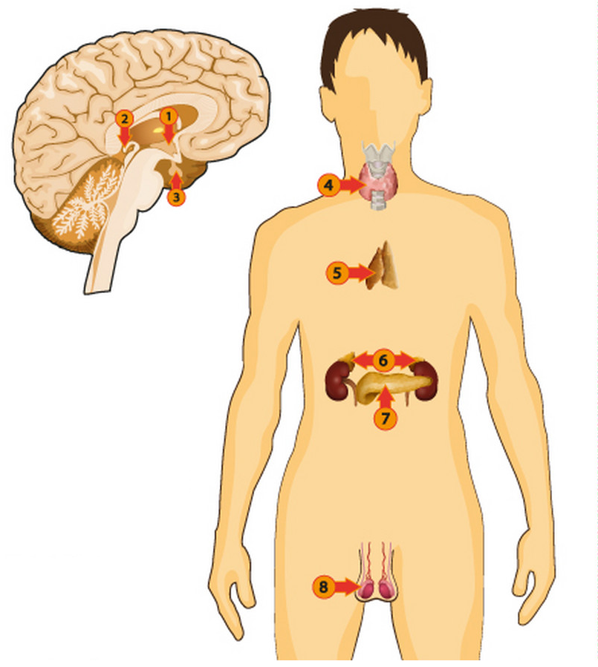

1. Provide the number of the endocrine gland in the diagram above that secretes the hormone

i) ADH. (1 mark)

________________________________________________________________________

ii) aldosterone. (1 mark)

_______________________________________________________________________

iii) thymosins. (1 mark)

_______________________________________________________________________

1. ADH and aldosterone both play an important role in the regulation of body fluid composition. Explain how these hormones can increase the water concentration of the blood plasma. (6 marks)

________________________________________________________________________________________________________________________________________________________________________________________________________________________________________________________________________________________________________________________________________________________________________________________________________________________________________________________________________________________________________________________________________________________________________________________________________________________

1. i) Using the space provided, draw and label a picture to show the different locations of blood plasma, intercellular fluid and intracellular fluid. (2 marks)

ii) List the fluids in order that the water molecules would travel through if the osmotic pressure of the blood plasma was low. (1 mark)

________________________________________________________________________

iii) If an individual has a very low osmotic pressure within their blood plasma, they may experience lightheadedness, vomiting and they could collapse. State what the name of this condition is and explain what the person could consciously do to correct their osmotic pressure. (2 marks)

____________________________________________________________________________________________________________________________________________________________________________________________________________________________________________________________________________________

**Question 34 (17 marks)**

Refer to the diagram below to answer the following questions.

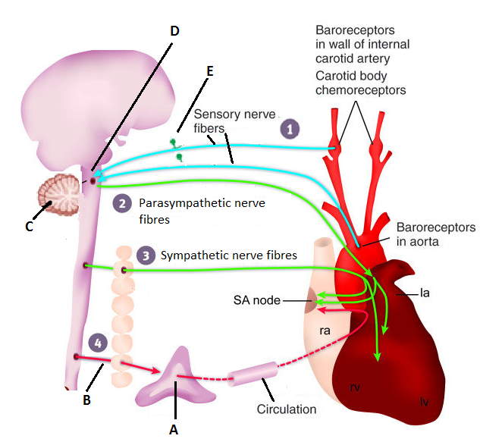

1. State the function of the carotid and aortic bodies. (1 mark)

________________________________________________________________________

________________________________________________________________________

1. Name the endocrine gland labelled “A” in the diagram. (1 mark)

________________________________________________________________________

1. Assuming the carotid and aortic bodies have been stimulated, complete the following table to identify similarities and differences between those parts labelled “A” and “B” in the diagram. (4 marks)

|  |  |  |  |  |
| --- | --- | --- | --- | --- |
| Part label | Nature of chemical message | Name of chemical released to transfer message | Effect chemical(s) has/have on target cells/organ | Time taken to respond. |
| A |  |  |  |  |
| B |  |  |  |  |

1. Complete the following table. (4 marks)

|  |  |  |
| --- | --- | --- |
| Brain Part label | Brain part name | Brain part function |
| C |  |  |
| D |  |  |

1. Identify the nerve fibre part shown as “E” in the diagram and state which parts of the nerve cell would be found within “Part E”. (2 marks)

________________________________________________________________________

________________________________________________________________________

1. The automatic response being shown in the diagram above is coordinated by the spinal cord and occurs as a result of a change in the internal environment. State the name of the type of response being shown in the diagram and describe the four properties these responses have in common. (5 marks)

________________________________________________________________________

________________________________________________________________________

________________________________________________________________________

________________________________________________________________________

________________________________________________________________________

________________________________________________________________________

**Question 35 (11 marks)**

Refer to the diagram below to answer Question 35.

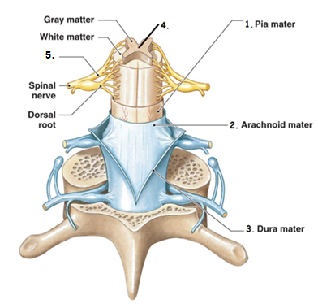

1. The parts labelled 1,2 and 3 in the diagram work together to protect the spinal cord. State the collective name used to identify these parts and describe three functions these layers carry out. (4 marks)

________________________________________________________________________

________________________________________________________________________

________________________________________________________________________

________________________________________________________________________

________________________________________________________________________

________________________________________________________________________

1. Identify the fluid within part 4 of the diagram and describe three functions of this fluid.

(4 marks)

________________________________________________________________________

________________________________________________________________________

________________________________________________________________________

________________________________________________________________________

________________________________________________________________________

________________________________________________________________________

1. Name the type of neurons that would be found within part 5 of the diagram and describe the roles played by these neurons. (3 marks)

________________________________________________________________________

________________________________________________________________________

________________________________________________________________________

________________________________________________________________________

**Question 36 (18 marks)**

Amoebic meningitis is a serious disease that leads to inflammation of the brain and can cause death. It’s caused by the *Naegleria fowleri* amoeba, pictured below.

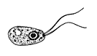

The Naegleria fowleri amoeba grows in warm, untreated water and flourishes in temperatures between 25°C and 40°C. It can be found in stagnant water such as lakes, neglected swimming pools and water hoses.

Amoebic meningitis infection happens if water containing the Naegleria fowleri amoeba is forced up the nose, via jumping or diving into the water. The amoeba can then make their way to the brain by attaching to and migrating along the olfactory sensory neurons, where it then causes inflammation and destroys brain tissue. You cannot get infected from swallowing contaminated water.

Some of the symptoms of a Naegleria fowleri amoeba infection include fever, vomiting, sore throat, stiff neck and seizures.

1. Looking at the diagram of the amoeba shown above, identify two reasons why it cannot be considered a virus. (2 marks)

________________________________________________________________________

________________________________________________________________________

1. Using the diagram below, circle the area of the brain where the *Naegleria fowleri* amoeba infection would initially begin and state why it would start there. (3 marks)

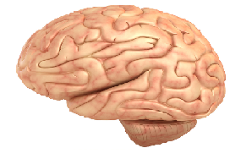

________________________________________________________________________

________________________________________________________________________

________________________________________________________________________

________________________________________________________________________

1. Identify a protective reflex someone with a *Naegleria fowleri* amoeba infection would experience and explain how this reflex would occur. (3 marks)

________________________________________________________________________

________________________________________________________________________

________________________________________________________________________

________________________________________________________________________

1. State why an infection cannot occur if someone swallows water with the amoeba in it.

(1 mark)

________________________________________________________________________

________________________________________________________________________

1. Explain how the amoeba would stimulate the body to develop a fever.

(5 marks)

________________________________________________________________________

________________________________________________________________________

________________________________________________________________________

________________________________________________________________________

________________________________________________________________________

________________________________________________________________________

1. Describe three reasons why a fever would normally reduce the number of pathogens within a body and state why the *Naegleria fowleri* amoeba would be resistant to a fever.

(4 marks)

________________________________________________________________________

________________________________________________________________________

________________________________________________________________________

________________________________________________________________________

________________________________________________________________________

________________________________________________________________________

**Section Three: Extended answer 20% (40 Marks)**

This section contains **three (3)** questions. You must answer **two (2)** questions. Make sure you clearly indicate which question you are answering and write your answers in the space provided.

Spare pages are included at the end of this booklet. They can be used for planning your responses and/or as additional space if required to continue an answer.

* Planning: If you use the spare pages for planning, indicate this clearly at the top of the page.
  + Continuing an answer: If you need to use more space to continue an answer, indicate in the original answer space where the answer is continued, i.e. give the page number. Write the number of the question(s) that you are continuing to answer at the top of the additional space page.

Responses could include clearly labelled diagrams with explanatory notes; lists of points with linking sentences; clearly labelled tables and graphs; and annotated flow diagrams with introductory notes.

Suggested working time: 40 minutes.

______________________________________________________________________________

**Question 37 (20 marks)**

All of the cells of the body require a continuous supply of glucose and oxygen for cellular respiration. The concentration of oxygen, carbon dioxide and hydrogen ions in the blood plasma all have some effect on the regulation of breathing.

1. Explain the relationship between carbon dioxide and hydrogen ions within the blood plasma and how hydrogen ions affect an individual’s breathing rate. (5 marks)
2. The muscles responsible for increasing an individual’s breathing rate require stimulation from nerve impulses. Explain how an action potential is transmitted along a myelinated nerve fibre.

(10 marks)

1. The liver has a very important role in the regulation of blood sugar concentration. Explain why the liver’s blood supply is high in carbohydrates and the roles the liver plays in maintaining blood sugar level. (5 marks)

**Question 38 (20 marks)**

When a person has finished a meal, their blood glucose levels can rise beyond the tolerance limits of the body. Homeostatic mechanisms are then required to reduce the blood glucose concentration and maintain it at the normal level, without excreting the glucose.

When the blood glucose levels are higher than normal, they are detected by sensory receptors, which then send an impulse to a modulator, which processes the information and informs the effector.

1. Explain how the impulses are chemically transmitted across the gap between the sensory receptor and the neuron of the modulator. (10 marks)

Type 1 and Type 2 diabetics can both reach blood glucose levels up to 200mg/dL, where extreme sensations of thirst can follow.

1. Explain why a Type 1 and Type 2 diabetic would get such high blood sugar levels and describe a homeostatic mechanism that would detect and rectify the excessive feelings of thirst. (10 marks)

**Question 39 (20 marks)**

An individual with cancer of the thyroid has had their thyroid removed and subsequently developed the following symptoms:

* unexplained weight gain,
* fatigue, especially in the afternoon and
* an intolerance to cold temperatures.

A fasting blood test has shown the patient has developed abnormally high levels of glucose, which has been linked to the patient developing insulin resistance, since having the surgery.

1. Identify the condition of the patient and explain why the patient would now be experiencing the three listed symptoms, being sure to make links to cellular processes and glucose metabolism to support your answer. (10 marks)
2. Scientific research has shown T lymphocytes are important in fighting cancer cells. Describe the immune response that would have occurred as the T lymphocytes responded to the thyroid cancer cells before they were removed. (10 marks)

Question number: ________________

______________________________________________________________________________________________________________________________________________________________________________________________________________________________________________________________________________________________________________________________________________________________________________________________________________________________________________________________________________________________________________________________________________________________________________________________________________________________________________________________________________________________________________________________________________________________________________________________________________________________________________________________________________________________________________________________________________________________________________________________________________________________________________________________________________________________________________________________________________________________________________________________________________________________________________________________________________________________________________________________________________________________________________________________________________________________________________________________________________________________________________________________________________________________________________________________________________________________________________________________________________________________________________________________________________________________________________________________________________________________________________________________________________________________________________________________________________________________________________________________________________________________________________________________________________________________________________________________________________________________________________________________________________________________________________________________________________________________________________________________________________________________________________________________________________________________________________________________________________________________________________________________________________________________________________________________________________________________________________________________________________________________________________________________________________________________________________________________________________________________________________________________________________________________________________________________________________________________________________________________________

Question number: ________________

______________________________________________________________________________________________________________________________________________________________________________________________________________________________________________________________________________________________________________________________________________________________________________________________________________________________________________________________________________________________________________________________________________________________________________________________________________________________________________________________________________________________________________________________________________________________________________________________________________________________________________________________________________________________________________________________________________________________________________________________________________________________________________________________________________________________________________________________________________________________________________________________________________________________________________________________________________________________________________________________________________________________________________________________________________________________________________________________________________________________________________________________________________________________________________________________________________________________________________________________________________________________________________________________________________________________________________________________________________________________________________________________________________________________________________________________________________________________________________________________________________________________________________________________________________________________________________________________________________________________________________________________________________________________________________________________________________________________________________________________________________________________________________________________________________________________________________________________________________________________________________________________________________________________________________________________________________________________________________________________________________________________________________________________________________________________________________________________________________________________________________________________________________________________________________________________________________________________________________________________________

Question number: ________________

______________________________________________________________________________________________________________________________________________________________________________________________________________________________________________________________________________________________________________________________________________________________________________________________________________________________________________________________________________________________________________________________________________________________________________________________________________________________________________________________________________________________________________________________________________________________________________________________________________________________________________________________________________________________________________________________________________________________________________________________________________________________________________________________________________________________________________________________________________________________________________________________________________________________________________________________________________________________________________________________________________________________________________________________________________________________________________________________________________________________________________________________________________________________________________________________________________________________________________________________________________________________________________________________________________________________________________________________________________________________________________________________________________________________________________________________________________________________________________________________________________________________________________________________________________________________________________________________________________________________________________________________________________________________________________________________________________________________________________________________________________________________________________________________________________________________________________________________________________________________________________________________________________________________________________________________________________________________________________________________________________________________________________________________________________________________________________________________________________________________________________________________________________________________________________________________________________________________________________________________________

Question number: ________________

_____________________________________________________________________________________________________________________________________________________________________________________________________________________________________________________________________________________________________________________________________________________________________________________________________________________________________________________________________________________________________________________________________________________________________________________________________________________________________________________________________________________________________________________________________________________________________________________________________________________________________________________________________________________________________________________________________________________________________________________________________________________________________________________________________________________________________________________________________________________________________________________________________________________________________________________________________________________________________________________________________________________________________________________________________________________________________________________________________________________________________________________________________________________________________________________________________________________________________________________________________________________________________________________________________________________________________________________________________________________________________________________________________________________________________________________________________________________________________________________________________________________________________________________________________________________________________________________________________________________________________________________________________________________________________________________________________________________________________________________________________________________________________________________________________________________________________________________________________________________________________________________________________________________________________________________________________________________________________________________________________________________________________________________________________________________________________________________________________________________________________________________________________________­­­­­­­___________________________________________­______________________________________________________________________________

Question number: ________________

______________________________________________________________________________________________________________________________________________________________________________________________________________________________________________________________________________________________________________________________________________________________________________________________________________________________________________________________________________________________________________________________________________________________________________________________________________________________________________________________________________________________________________________________________________________________________________________________________________________________________________________________________________________________________________________________________________________________________________________________________________________________________________________________________________________________________________________________________________________________________________________________________________________________________________________________________________________________________________________________________________________________________________________________________________________________________________________________________________________________________________________________________________________________________________________________________________________________________________________________________________________________________________________________________________________________________________________________________________________________________________________________________________________________________________________________________________________________________________________________________________________________________________________________________________________________________________________________________________________________________________________________________________________________________________________________________________________________________________________________________________________________________________________________________________________________________________________________________________________________________________________________________________________________________________________________________________________________________________________________________________________________________________________________________________________________________________________________________________________________________________________________________________________________________________________________________________________________________________________________________

Additional working space

Question number: ________________

__________________________________________________________________________________________________________________________________________________________________________________________________________________________________________________________________________________________________________________________________________________________________________________________________________________________________________________________________________________________________________________________________________________________________________________________________________________________________________________________________________________________________________________________________________________________________________________________________________________________________________________________________________________________________________________________________________________________________________________________________________________________________________________________________________________________________________________________________________________________________________________________________________________________________________________________________________________________________________________________________________________________________________________________________________________________________________________________________________________________________________________________________________________________________________________________________________________________________________________________________________________________________________________________________________________________________________________________________________________________________________________________________________________________________________________________________________________________________________________________________________________________________________________________________________________________________________________________________________________________________________________________________________________________________________________________________________________________________________________________________________________________________________________________________________________________________________________________________________________________________________________________________________________________________________________________________________________________________________________________________________________________________________________________________________________________________________________________________________________________________________

Additional working space

Question number: ________________

__________________________________________________________________________________________________________________________________________________________________________________________________________________________________________________________________________________________________________________________________________________________________________________________________________________________________________________________________________________________________________________________________________________________________________________________________________________________________________________________________________________________________________________________________________________________________________________________________________________________________________________________________________________________________________________________________________________________________________________________________________________________________________________________________________________________________________________________________________________________________________________________________________________________________________________________________________________________________________________________________________________________________________________________________________________________________________________________________________________________________________________________________________________________________________________________________________________________________________________________________________________________________________________________________________________________________________________________________________________________________________________________________________________________________________________________________________________________________________________________________________________________________________________________________________________________________________________________________________________________________________________________________________________________________________________________________________________________________________________________________________________________________________________________________________________________________________________________________________________________________________________________________________________________________________________________________________________________________________________________________________________________________________________________________________________________________________________________________________________________________________

Spare graph for question 32

|  |  |  |  |  |  |  |  |  |  |  |  |  |  |  |  |
| --- | --- | --- | --- | --- | --- | --- | --- | --- | --- | --- | --- | --- | --- | --- | --- |
|  |  |  |  |  |  |  |  |  |  |  |  |  |  |  |  |
|  |  |  |  |  |  |  |  |  |  |  |  |  |  |  |  |
|  |  |  |  |  |  |  |  |  |  |  |  |  |  |  |  |
|  |  |  |  |  |  |  |  |  |  |  |  |  |  |  |  |
|  |  |  |  |  |  |  |  |  |  |  |  |  |  |  |  |
|  |  |  |  |  |  |  |  |  |  |  |  |  |  |  |  |
|  |  |  |  |  |  |  |  |  |  |  |  |  |  |  |  |
|  |  |  |  |  |  |  |  |  |  |  |  |  |  |  |  |
|  |  |  |  |  |  |  |  |  |  |  |  |  |  |  |  |
|  |  |  |  |  |  |  |  |  |  |  |  |  |  |  |  |
|  |  |  |  |  |  |  |  |  |  |  |  |  |  |  |  |
|  |  |  |  |  |  |  |  |  |  |  |  |  |  |  |  |
|  |  |  |  |  |  |  |  |  |  |  |  |  |  |  |  |
|  |  |  |  |  |  |  |  |  |  |  |  |  |  |  |  |
|  |  |  |  |  |  |  |  |  |  |  |  |  |  |  |  |
|  |  |  |  |  |  |  |  |  |  |  |  |  |  |  |  |
|  |  |  |  |  |  |  |  |  |  |  |  |  |  |  |  |
|  |  |  |  |  |  |  |  |  |  |  |  |  |  |  |  |
|  |  |  |  |  |  |  |  |  |  |  |  |  |  |  |  |

Multichoice question 4

Picture of neuron from - https://www.shutterstock.com/search/....

Under the Shutterstock license

Multichoice question 8-10

https://busy.org/@ovij/mystifact-or-fiction-challenge-1-orgasmic-....

Under the Creative Commons License

Question 33

Endocrine system - <https://www.vectorstock.com/royalty-free-vector/endocrine-system-image-vector-17446906>

Under the Free Images License.

Question 34

Parasympathetic/sympathetic nervous system with heart diagram

<https://www.researchgate.net/figure/Diagram-of-sympathetic-and-parasympathetic-regulation-of-the-baroreceptor-reflex_fig7_41577425>

Under the Creative Commons License

Question 35 (a)

Spinal cord diagram

<https://www.medicosite.com/........../>

Under the Dreamstime License

Question 36 (c).

Naegleria fowleri diagram

<https://en.wikipedia.org/wiki/Naegleria_fowleri>

Under the Creative Commons License

Question 36 (d)

Brain diagram

<https://www.livescience.com/29365-human-brain.html>

Under the Creative Commons License